Laba 2. JS

<!DOCTYPE html>

<html lang="en">

<head>

    <meta charset="UTF-8">

    <meta http-equiv="X-UA-Compatible" content="IE=edge">

    <meta name="viewport" content="width=device-width, initial-scale=1.0">

    <title>Document</title>

</head>

<body>

    <!--HTML comment-->

    <noscript>TAke on the JS</noscript>

    <script>

        //JS comment

        /* 2 JS comment

        where i can write

        2+ string */

    </script>

</body>

</html>

Picture 1. JS comments

<!DOCTYPE html>

<html lang="en">

<head>

    <meta charset="UTF-8">

    <meta http-equiv="X-UA-Compatible" content="IE=edge">

    <meta name="viewport" content="width=device-width, initial-scale=1.0">

    <title>Document</title>

</head>

<body>

    <h1 class="main h"></h1>

    <script>

        document.write("JS output")

    </script>

</body>

</html>

Picture 2. JS output



Picture 3. Html output

<!DOCTYPE html>

<html lang="en">

<head>

    <meta charset="UTF-8">

    <meta http-equiv="X-UA-Compatible" content="IE=edge">

    <meta name="viewport" content="width=device-width, initial-scale=1.0">

    <title>Document</title>

</head>

<body>

    <script src="js/main.js"></script>

</body>

</html>

Picture 4. HTML code

document.write("JS output")

console.info("JS info output")

console.error("JS error in console")

console.log("JS output in console ")

console.warn("JS output in console with take warn of user")

Picture 5. JS code

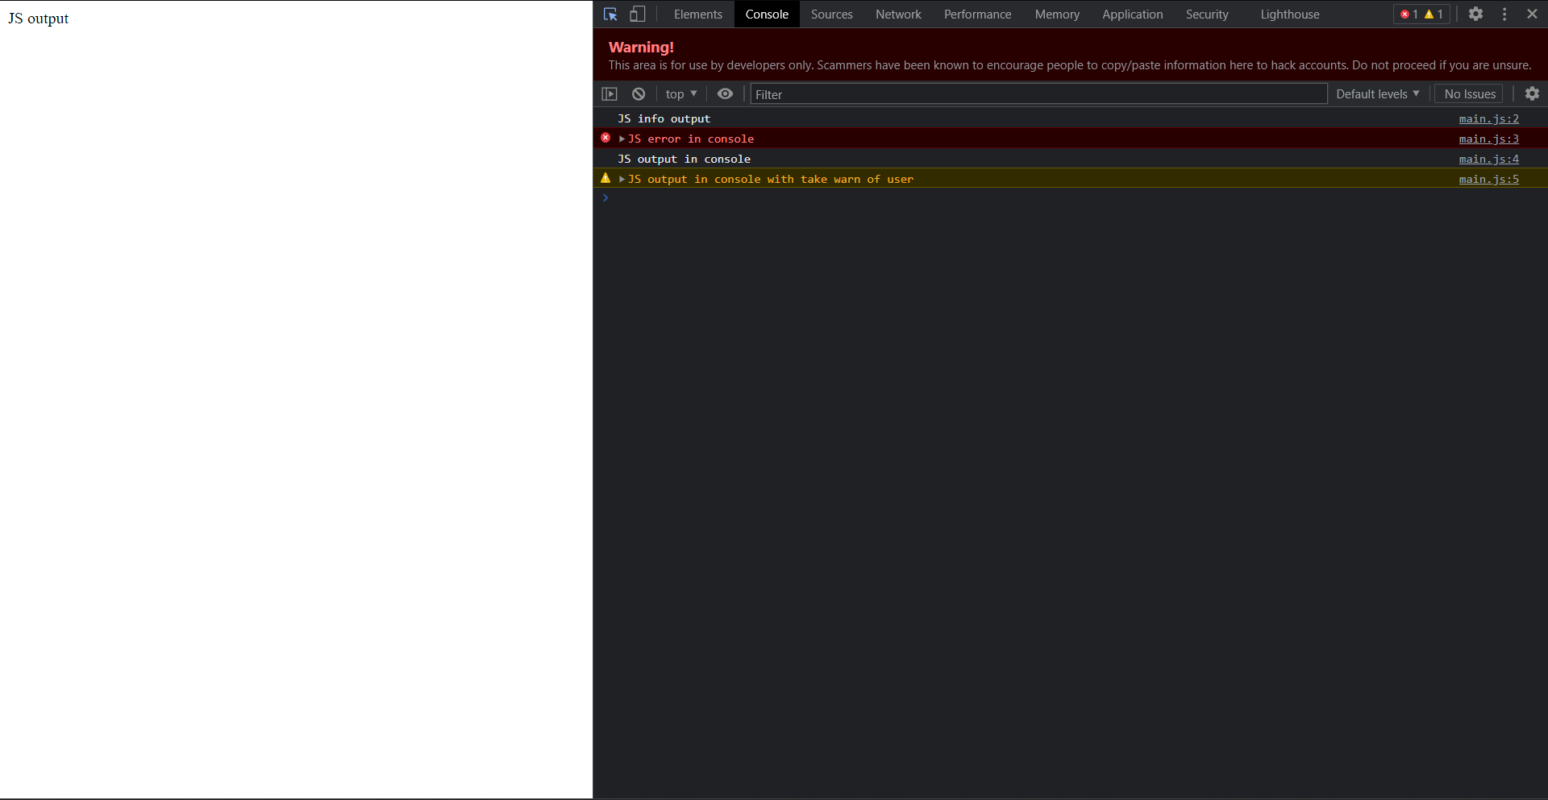

Picture 6. Site picture

var num = 5;

num = 5 - 2;

console.log("Переменная: " + num);

const num1 = 12;

num1 = 11;

console.log("Константа: " + num1);

var number;

number = false;

console.log(number);

var num_1 = 5; // тип данных int

var num_2 = "5"; //тип данных string

Picture 7. Local variable